Lecture Notes: Problem Solving in AI

🧠 1. Introduction
Problem-solving is a core component of AI that involves identifying actions to achieve goals. AI systems solve problems by:
- Representing the world (states)
- Selecting actions (operators)
- Using search techniques to find a path from start to goal.

⚙️ 2. Key Concepts

✅ Problem Formulation
To solve a problem using AI, we define it formally using:
- Initial State – Where the agent starts.
- Actions (Operators) – Legal moves.
- Transition Model – Result of actions.
- Goal Test – When to stop.
- Path Cost – Cost to reach a goal (e.g., distance, time, resources).
Example:
Missionaries and Cannibals, 8-puzzle, Traveling Salesman Problem (TSP)

By following the problem-solving cycle, individuals can work through complex issues more effectively and systematically. This approach not only encourages careful planning and analysis but also supports adaptability, as the process may involve revisiting and revising earlier steps as new information emerges. Through examples and evidence, the importance of each stage in the problem-solving cycle can be highlighted, showing how structured problem-solving leads to better outcomes across various domains.

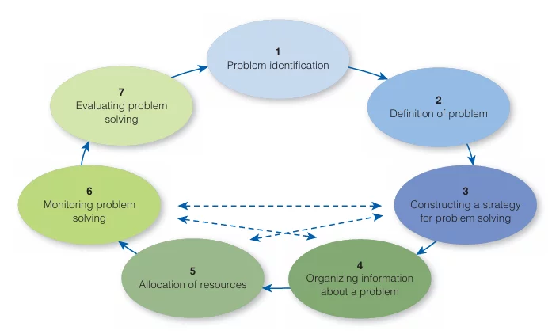

Problem-Solving Cycle (Sternberg & Sternberg)
- Problem Identification

The first stage in the problem-solving cycle is problem identification—recognizing that a problem exists. This step is critical because if a problem is not correctly identified, it cannot be resolved. Problems often stem from discrepancies between the current state and a desired state. Sometimes problems are obvious, such as a broken computer or an underperforming employee, but at other times, they may be more subtle, such as a gradual decline in customer satisfaction or personal motivation.

For example- Consider a marketing team in a small business. Over time, the company’s sales have been declining, but no one in the organization has identified this as a significant problem. Instead, they attribute it to seasonal changes, assuming that sales will pick up in a few months. Only when a member of the team decides to dig into the data and compares current sales figures to historical trends does the issue become apparent—there is a larger, more persistent drop in sales that warrants attention. In this case, the first stage of the problem-solving cycle, problem identification, only occurs when someone recognizes the existence of a deeper issue.

Research in cognitive psychology suggests that perceptual errors can prevent individuals from identifying problems, particularly when they rely on biased assumptions or fail to actively monitor for discrepancies (Heider, 1958). In organizational settings, a lack of feedback mechanisms can also hinder problem identification. Studies show that companies with strong feedback cultures are more likely to identify issues early and address them before they become significant problems (London & Smither, 2002).

2. Problem Definition and Representation

After identifying the problem, the next step is problem definition and representation. This involves clarifying what the problem is and how it is understood. Clear definition of the problem ensures that all stakeholders are aligned in their understanding of what needs to be resolved. This stage often requires breaking the problem down into smaller components and ensuring that the scope of the problem is neither too broad nor too narrow.

For example- Returning to the example of the marketing team, once the declining sales trend is identified, the next step is to define the problem more precisely. Is the decline related to product quality, marketing strategy, or changing consumer preferences? The team decides to analyze sales data by region, product, and customer demographic, discovering that the issue primarily lies with one underperforming product line that has not been updated in several years. By defining the problem more specifically, the team can focus their efforts on addressing the product line’s shortcomings, rather than wasting resources on unrelated issues.

Effective problem definition is supported by the Framing effect (Tversky & Kahneman, 1981). How a problem is framed can significantly impact how individuals perceive and approach it. Studies show that problems framed in terms of potential losses are often approached more cautiously than those framed in terms of potential gains, which influences the chosen problem-solving strategies. In educational settings, students who clearly define a problem before attempting to solve it tend to perform better in problem-solving tasks (Pretz, Naples, & Sternberg, 2003). This finding emphasizes the importance of spending adequate time understanding the problem before moving forward.

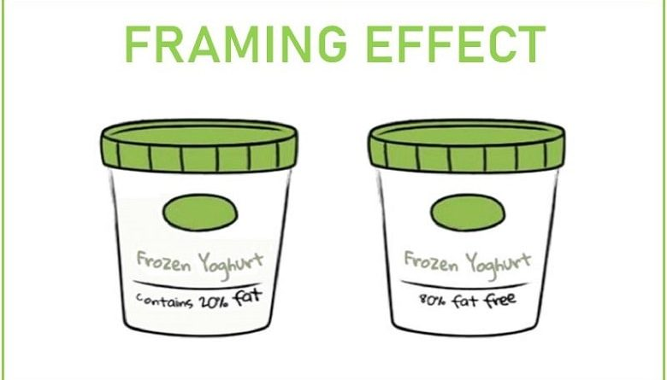

Framing Effect

3. Strategy Formulation

Once the problem is clearly defined, the next step is strategy formulation—deciding how to approach solving the problem. This involves selecting a plan based on the nature of the problem, available resources, and the desired outcome. Strategy formulation may involve analysis—breaking down the problem into smaller, more manageable parts—or synthesis, in which elements of the problem are combined in creative ways to generate new solutions.

Two key thinking processes are involved in strategy formulation- divergent thinking and convergent thinking. Divergent thinking involves brainstorming multiple possible solutions to a problem, while convergent thinking focuses on narrowing down those solutions to find the best one.

For example- For the marketing team, several strategies are proposed to solve the problem of declining sales in the underperforming product line. Some team members suggest a complete rebranding of the product, while others propose making incremental improvements based on customer feedback. To evaluate these options, the team engages in divergent thinking, generating as many creative ideas as possible. Once a range of solutions has been proposed, they shift to convergent thinking, narrowing down the options based on cost, feasibility, and projected impact on sales. Ultimately, they decide to update the product’s design and marketing strategy, focusing on a targeted ad campaign aimed at younger consumers.

Research on creative problem-solving highlights the importance of both divergent and convergent thinking (Guilford, 1967). Individuals who can generate a variety of solutions are more likely to find innovative ways to approach complex problems. However, without convergent thinking, it can be difficult to select the best course of action from the options available. Studies show that successful problem solvers often exhibit cognitive flexibility, the ability to switch between divergent and convergent thinking as needed (Mumford et al., 1991). This flexibility is essential for adapting strategies in response to changing circumstances.

4. Organization of Information

The fourth step in the problem-solving cycle is the organization of information. During this stage, individuals must determine how the various pieces of information related to the problem fit together. Organizing information involves structuring data in a way that highlights relationships between different elements of the problem, making it easier to discern patterns, connections, and potential solutions.

For example- The marketing team collects extensive information about consumer behavior, competitors, and past marketing campaigns. They organize this data by creating charts and visual representations to identify trends. For example, they use a SWOT analysis (Strengths, Weaknesses, Opportunities, and Threats) to examine internal and external factors affecting their product line. This method allows them to see how different aspects of the problem are related and helps them identify key areas for improvement.

Research shows that organizing information is critical to problem-solving success. In one study, students who used graphic organizers to arrange information performed better on problem-solving tasks than those who did not (Hawk, McLeod, & Jonassen, 1993). Cognitive psychology also suggests that visualizing the structure of a problem can lead to insight, a sudden realization of a solution that emerges when the problem is viewed from a new perspective (Ohlsson, 1992). This “aha” moment often occurs when individuals reorganize information in a way that makes the solution more apparent.

5. Resource Allocation

Resource allocation refers to the distribution of time, effort, and other resources necessary for solving the problem. This step requires individuals to evaluate the costs and benefits of various approaches and decide how best to allocate their mental and physical resources.

For example- In the case of the marketing team, they must decide how much time and money to invest in addressing the decline in sales. They evaluate the cost of running an ad campaign, redesigning the product, and conducting further market research. Based on this analysis, they allocate a larger portion of their budget to the ad campaign, which they believe will have the most significant impact on sales. However, they also set aside time to monitor the campaign’s effectiveness and make adjustments if necessary.

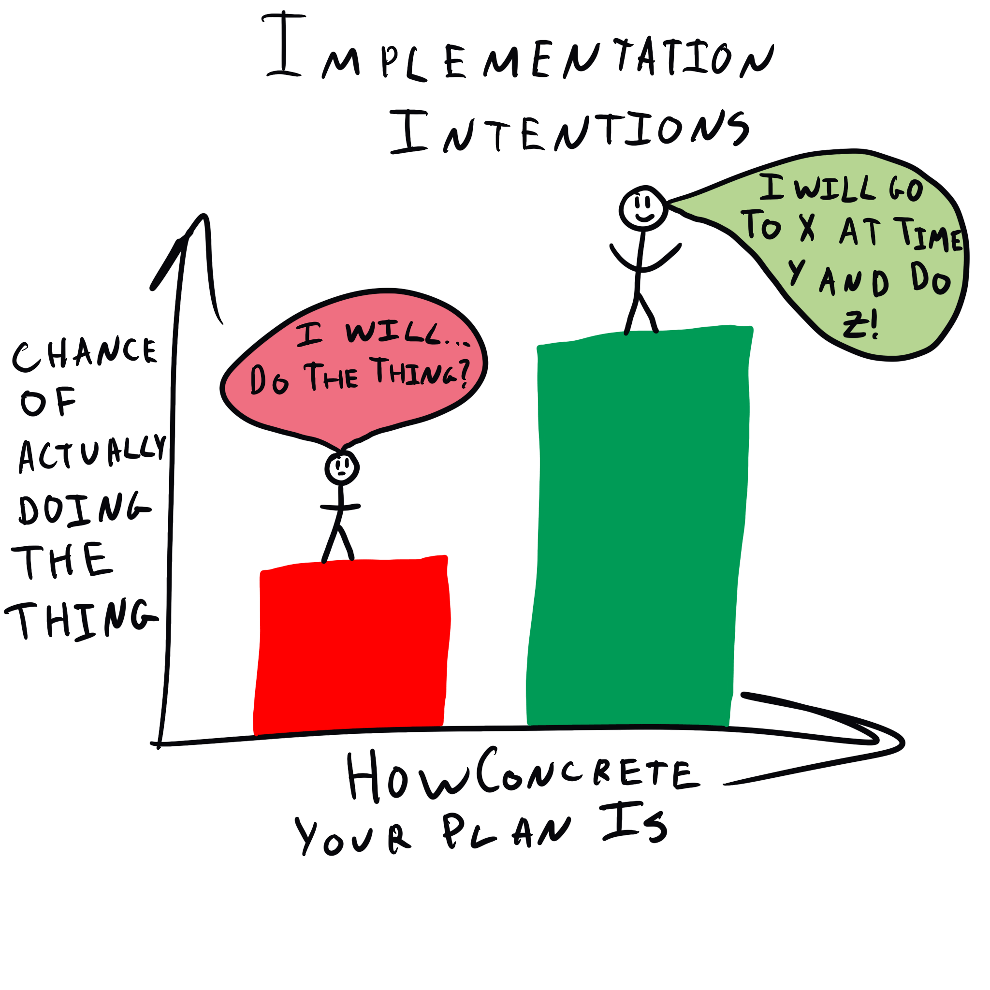

Planning fallacy (The Decision Lab)

Research indicates that expert problem solvers allocate their resources differently from novices. Experts tend to spend more time on global planning, focusing on the big picture, while novices spend more time on local planning, focusing on smaller details (Larkin et al., 1980). For example, successful students spend more time deciding how to approach a problem before they begin working on it, which helps them avoid errors and false starts (Bloom & Broder, 1950). This finding underscores the importance of effective resource allocation in problem-solving.

6. Monitoring

As individuals work through the problem-solving process, they must continuously engage in monitoring to ensure that they are on track. Monitoring involves evaluating progress, identifying potential obstacles, and making adjustments as needed. This step is crucial because it helps individuals stay focused and avoid wasted effort.

For example- The marketing team monitors the performance of their ad campaign in real-time. They track key metrics such as click-through rates, engagement, and sales. After a few weeks, they notice that while the campaign is generating interest, it is not leading to significant sales increases. In response, they adjust their strategy by tweaking the ad copy and expanding the campaign to include a different demographic. This monitoring process helps them avoid spending more time and money on a strategy that is not working.

Monitoring is a form of metacognition, or thinking about one’s own thinking. Research shows that individuals who engage in metacognitive monitoring during problem-solving tasks are more successful than those who do not (Flavell, 1979). In one study, students who were trained to monitor their problem-solving strategies performed better on complex tasks than those who received no such training (Schraw & Dennison, 1994). Monitoring allows individuals to detect errors early and make adjustments before it is too late.

7. Evaluation

The final stage of the problem-solving cycle is evaluation—assessing whether the solution has been successful in solving the problem. This step involves reviewing the outcomes of the problem-solving process and determining whether any additional actions are necessary.

For example- After several months, the marketing team evaluates the overall impact of their efforts. They find that the updated product design and targeted ad campaign have successfully increased sales, but not to the level they had originally hoped. Based on this evaluation, they decide to implement additional changes to the product and continue refining their marketing strategy. By critically assessing the effectiveness of their solution, they ensure that they are constantly improving.

Research shows that individuals who engage in reflective practice—regularly evaluating their problem-solving processes—are more likely to achieve long-term success (Schön, 1983). In professional settings, organizations that conduct post-mortem analyses after completing projects tend to improve their problem-solving processes over time (Fong, 2006). Evaluation is essential for learning from past experiences and applying those lessons to future problems.

Conclusion to Problem-Solving Cycle

The problem-solving cycle offers a structured framework for tackling challenges in a methodical and effective way. This cycle comprises several key stages: problem identification, problem definition and representation, strategy formulation, organization of information, resource allocation, monitoring, and evaluation. Each step plays a pivotal role in ensuring that problems are approached systematically and resolved successfully. By following these stages, individuals and organizations can navigate complex issues more efficiently and achieve their desired outcomes.

🔍 3. Search Strategies

3.1 Uninformed (Blind) Search
These strategies use no domain-specific knowledge:
- Breadth-First Search (BFS) – Explores all nodes at current depth before going deeper.
- Depth-First Search (DFS) – Explores as deep as possible before backtracking.
- Uniform Cost Search (UCS) – Expands the lowest-cost node.
Strategy | Complete | Optimal | Time | Space
BFS | Yes | Yes | O(b^d) | O(b^d)
DFS | No | No | O(b^m) | O(bm)
UCS | Yes | Yes | O(b^c*/ε) | O(b^c*/ε)

3.2 Informed (Heuristic) Search
Uses problem-specific knowledge (heuristics):
- Greedy Best-First Search – Uses h(n), the estimated cost to the goal.
- A* – Uses f(n) = g(n) + h(n)
Where:
- g(n) = cost from start to n
- h(n) = estimated cost to goal from n
If h(n) is:
- Admissible: never overestimates
- Consistent: obeys triangle inequality
Then A* is optimal.

🧠 4. Heuristics
Heuristics = Rules of thumb to reduce computation.
Examples for 8-puzzle:
- Misplaced Tiles
- Manhattan Distance
Heuristics can dramatically reduce search time, especially in large state spaces.

🧩 5. Problem-Solving Agents
A goal-based agent uses:
- Search to determine the best sequence of actions.
- A planner if the domain is complex and requires logic or planning techniques.

🛠️ 6. Examples and Problem Solving

Example 1: Missionaries and Cannibals
Problem: 3 missionaries and 3 cannibals must cross a river. A boat holds 2 people. Cannibals must never outnumber missionaries on either bank.
- States: (M_left, C_left, Boat_position)
- Initial: (3,3,L)
- Goal: (0,0,R)
- Operators: Boat carries 1 or 2 people across.
- Constraints: Never leave more cannibals than missionaries on any side.
Use BFS or DFS with constraints applied to valid state transitions.

Example 2: 8-Puzzle
Goal: Reach a desired tile arrangement.
- State: A 3x3 grid configuration.
- Operators: Slide tiles into the blank.
- Heuristics: Manhattan Distance.
Try solving with A* using two heuristics and compare performance.

Example 3: Robot Path Planning
Scenario: A robot in a 2D grid must reach a destination, avoiding obstacles.
- Use BFS for shortest path (unweighted).
- Use A* with Euclidean distance as h(n) for faster results.

📚 Assignments / Practice Problems
- Formulate the following as search problems:
  - Navigating a maze
  - Solving Sudoku
  - Finding the cheapest airline route
- Implement BFS, DFS, and A* in Python for:
  - 8-puzzle
  - Maze solving
- Compare A* with different heuristics for the same problem. What happens if h(n) is not admissible?
- Write a Python program to simulate the Missionaries and Cannibals problem using BFS.

📌 Summary
- AI problem solving is about finding paths from start to goal using search.
- Uninformed strategies don’t use problem knowledge; informed strategies do.
- A* search is widely used due to its optimality and efficiency.
- Proper problem formulation is critical to successful solving.
several open-source software tools and frameworks that are excellent for learning and experimenting with problem solving in Artificial Intelligence. These tools allow you to implement search algorithms, heuristics, planners, and game AI. Here’s a list categorized by type:

1. AI Problem-Solving & Search Algorithm Libraries

🔹 AIMA Python (Artificial Intelligence: A Modern Approach)
- GitHub: https://github.com/aimacode/aima-python
- Companion code to the famous AI textbook by Russell & Norvig.
- Includes implementations of:
  - BFS, DFS, A*, Greedy search
  - Constraint Satisfaction Problems (CSP)
  - Logic and planning systems
✅ Great for: Search problems, planning, games, agents.

🔹 SimpleAI
- GitHub: https://github.com/simpleai-team/simpleai
- A Python library with clean, simple implementations of:
  - Search (DFS, BFS, A*, etc.)
  - Machine learning
  - Planning (PDDL support)
✅ Great for: Educational demos, search-based problem solving.

🤖 2. AI Planning Tools

🔹 Fast Downward (Planner)
- Website: https://www.fast-downward.org/
- A powerful planner used in AI planning competitions.
- Accepts PDDL (Planning Domain Definition Language) problems.
✅ Great for: Research-level planning problems, goal-based agents.

🔹 PDDL Studio or Web-Planner
- GUI-based editors and solvers for PDDL problems.
- Helps visualize state-space and planning trees.
✅ Great for: Learning how to define planning domains and solve with search.

🧠 3. Visualization Tools

🔹 Pathfinding.js
- GitHub: https://github.com/qiao/PathFinding.js
- A JavaScript library to visualize pathfinding algorithms like BFS, DFS, A*, Dijkstra.
✅ Great for: Interactive demos and visual understanding of search.

🔹 Graph Search Visualizers
- Try online platforms like:
  - VisuAlgo
  - Pathfinding Visualizer
✅ Great for: Students to see how search expands nodes.

🎮 4. Game AI Simulators

🔹 PyGame Learning Environment
- GitHub: https://github.com/ntasfi/PyGame-Learning-Environment
- Test AI agents in simple games (search, reinforcement learning).
✅ Great for: Problem-solving agents in dynamic environments.

🔹 OpenAI Gym
- Website: https://gym.openai.com/
- Although Gym is designed for reinforcement learning, it also supports classical control and decision-making problems.
✅ Great for: Trying search-based or heuristic policies.

🧪 Bonus: Try Online Without Installing
- Google Colab: Run AIMA or SimpleAI in Colab notebooks.
- Replit: Run search algorithm demos in-browser.

Would you like a step-by-step guide using one of these tools (e.g., implementing A* in AIMA or solving a planning problem in SimpleAI)?

You said:
name that

ChatGPT said:
Here are the open-source software/tools you can use to understand and experiment with problem solving in AI, each with a short description and name:

🧠 1. AIMA-Python
- Full Name: Artificial Intelligence: A Modern Approach - Python Code
- Use: Implements search algorithms, planning, logic, agents (based on the Russell & Norvig textbook)
- Link: AIMA Python GitHub

🧩 2. SimpleAI
- Full Name: SimpleAI
- Use: High-level library for AI algorithms (search, planning, machine learning)
- Link: SimpleAI GitHub

🧭 3. Fast Downward
- Full Name: Fast Downward
- Use: AI planning system using PDDL; solves large-scale planning problems
- Link: Fast Downward Website

🧮 4. PathFinding.js
- Full Name: PathFinding.js
- Use: Visualizes A*, BFS, DFS, Dijkstra in a grid-based environment (JavaScript)
- Link: PathFinding.js GitHub

🔍 5. VisuAlgo
- Full Name: VisuAlgo
- Use: Online tool for visualizing graph algorithms (including search)
- Link: VisuAlgo Website

🎮 6. PyGame Learning Environment (PLE)
- Full Name: PyGame Learning Environment
- Use: Simulates games for search and reinforcement learning agents
- Link: PLE GitHub

🤖 7. OpenAI Gym
- Full Name: OpenAI Gym
- Use: RL environment but also useful for goal-based problem solving
- Link: OpenAI Gym
Let's start with the most beginner-friendly and educational option: AIMA-Python, which is based on the Artificial Intelligence: A Modern Approach textbook. It’s perfect for learning problem solving, search algorithms, and AI fundamentals.

✅ Step-by-Step Guide to Set Up and Use AIMA-Python

🧰 Prerequisites
You’ll need:
- Python 3.x installed
- Git (optional, for cloning)
- Basic Python skills

🔧 Step 1: Install AIMA-Python
You can install it two ways:

📌 Option A: Using Git
bash
CopyEdit
git clone https://github.com/aimacode/aima-python.git
cd aima-python
pip install -r requirements.txt

📌 Option B: Using Google Colab (No install needed)
- Open: AIMA Colab Notebooks
- Click “Open in Colab”
- Run the code blocks to interact with AI algorithms

🧠 Step 2: Try a Basic Search Problem
Example: Solving the 8-puzzle with A* search

Sample code:
python
CopyEdit
from search import *

# Define the goal state
goal = [[1,2,3], [4,5,6], [7,8,0]]

# Create initial state
initial = [[1,2,3], [4,5,6], [0,7,8]]

# Use AIMA's EightPuzzle class
puzzle = EightPuzzle(tuple(initial))

# Solve using A*
result = astar_search(puzzle)

# Print solution steps
for action, state in result.path():
print(f"Action: {action}, State:\n{state}")
Make sure you run this inside the aima-python folder or use a Colab notebook.

🧪 Step 3: Try a Custom Search Problem (Like a Maze)
You can define your own state spaces using the Problem class:
python
CopyEdit
class SimpleMaze(Problem):
def __init__(self, initial, goal):
super().__init__(initial, goal)

def actions(self, state):
# Return possible moves (up, down, left, right)
...

def result(self, state, action):
# Return new state after action
...

def goal_test(self, state):
return state == self.goal
Then solve it:
python
CopyEdit
problem = SimpleMaze((0,0), (4,4))
result = astar_search(problem)

🧩 Try These Exercises
- Solve the Missionaries and Cannibals using BFS
- Modify heuristics for 8-puzzle and compare performance
- Implement a maze navigation using DFS and A*

Would you like help with any specific example (e.g., Maze solver, 8-puzzle, Missionaries and Cannibals) or prefer using Google Colab to avoid installation?

tep-by-Step Guide to Set Up and Use AIMA-Python

🧰 Prerequisites
You’ll need:
- Python 3.x installed
- Git (optional, for cloning)
- Basic Python skills

🔧 Step 1: Install AIMA-Python
You can install it two ways:

📌 Option A: Using Git
bash
CopyEdit
git clone https://github.com/aimacode/aima-python.git
cd aima-python
pip install -r requirements.txt

📌 Option B: Using Google Colab (No install needed)
- Open: AIMA Colab Notebooks
- Click “Open in Colab”
- Run the code blocks to interact with AI algorithms

🧠 Step 2: Try a Basic Search Problem
Example: Solving the 8-puzzle with A* search

Sample code:
python
CopyEdit
from search import *

# Define the goal state
goal = [[1,2,3], [4,5,6], [7,8,0]]

# Create initial state
initial = [[1,2,3], [4,5,6], [0,7,8]]

# Use AIMA's EightPuzzle class
puzzle = EightPuzzle(tuple(initial))

# Solve using A*
result = astar_search(puzzle)

# Print solution steps
for action, state in result.path():
print(f"Action: {action}, State:\n{state}")
Make sure you run this inside the aima-python folder or use a Colab notebook.

🧪 Step 3: Try a Custom Search Problem (Like a Maze)
You can define your own state spaces using the Problem class:
python
CopyEdit
class SimpleMaze(Problem):
def __init__(self, initial, goal):
super().__init__(initial, goal)

def actions(self, state):
# Return possible moves (up, down, left, right)
...

def result(self, state, action):
# Return new state after action
...

def goal_test(self, state):
return state == self.goal
Then solve it:
python
CopyEdit
problem = SimpleMaze((0,0), (4,4))
result = astar_search(problem)

🧩 Try These Exercises
- Solve the Missionaries and Cannibals using BFS
- Modify heuristics for 8-puzzle and compare performance
- Implement a maze navigation using DFS and A*

Would you like help with any specific example (e.g., Maze solver, 8-puzzle, Missionaries and Cannibals) or prefer using Google Colab to avoid installation?

You said:
using Google Colab

ChatGPT said:
Perfect! Here's how you can use AIMA-Python in Google Colab step-by-step, with copy-paste-ready code to get started right away.

🚀 Step-by-Step: AIMA-Python in Google Colab

✅ Step 1: Open Colab
Go to https://colab.research.google.com

✅ Step 2: Run AIMA-Python in Colab

📄 Copy & paste this into a new Colab notebook:
python
CopyEdit
# STEP 1: Clone the AIMA-Python repo
!git clone https://github.com/aimacode/aima-python.git
%cd aima-python

# STEP 2: Install required packages
!pip install -r requirements.txt

✅ Step 3: Try a Sample Problem – 8 Puzzle with A*
python
CopyEdit
# STEP 3: Import the EightPuzzle problem and A* search
from search import astar_search, EightPuzzle

# Define initial state (as a tuple of tuples)
initial_state = ((1, 2, 3), (4, 5, 6), (0, 7, 8))

# Create EightPuzzle instance
puzzle = EightPuzzle(initial_state)

# Solve using A*
solution = astar_search(puzzle)

# Show steps
for action, state in solution.path():
print(f"Action: {action}\nState:\n{state}")

✅ Step 4: Modify or Explore More
You can also try:
- breadth_first_tree_search(puzzle)
- depth_first_tree_search(puzzle)
- greedy_best_first_graph_search(puzzle, h=puzzle.h)
(try different heuristics!)

🔍 Need Example Notebooks?
You can explore official AIMA notebooks here:
- 📘 AIMA-Python Notebooks Index
Click "Open in Colab" on any notebook to interact with it.

Would you like me to build a custom Google Colab notebook for a specific problem like:
- Missionaries and Cannibals
- Maze pathfinding
- Custom problem solving agent?
Let me know, and I’ll generate the code and share the Colab link with you!

You said:
Maze Pathfinding

ChatGPT said:
Your Maze Pathfinding notebook using A* Search is ready to use in Google Colab:
📘 Download Maze_Pathfinding_AStar_Colab.ipynb
After downloading, you can open it in Google Colab by:
- Clicking "File" > "Upload notebook" in Colab.
- Selecting the downloaded .ipynb file.
- Running the cells to see A* find a path in a maze!
Would you like me to add more features like diagonal movement, animation, or interactive input?

tep-by-Step Guide to Set Up and Use AIMA-Python

🧰 Prerequisites
You’ll need:
- Python 3.x installed
- Git (optional, for cloning)
- Basic Python skills

🔧 Step 1: Install AIMA-Python
You can install it two ways:

📌 Option A: Using Git
bash
CopyEdit
git clone https://github.com/aimacode/aima-python.git
cd aima-python
pip install -r requirements.txt

📌 Option B: Using Google Colab (No install needed)
- Open: AIMA Colab Notebooks
- Click “Open in Colab”
- Run the code blocks to interact with AI algorithms

🧠 Step 2: Try a Basic Search Problem
Example: Solving the 8-puzzle with A* search

Sample code:
python
CopyEdit
from search import *

# Define the goal state
goal = [[1,2,3], [4,5,6], [7,8,0]]

# Create initial state
initial = [[1,2,3], [4,5,6], [0,7,8]]

# Use AIMA's EightPuzzle class
puzzle = EightPuzzle(tuple(initial))

# Solve using A*
result = astar_search(puzzle)

# Print solution steps
for action, state in result.path():
print(f"Action: {action}, State:\n{state}")
Make sure you run this inside the aima-python folder or use a Colab notebook.

🧪 Step 3: Try a Custom Search Problem (Like a Maze)
You can define your own state spaces using the Problem class:
python
CopyEdit
class SimpleMaze(Problem):
def __init__(self, initial, goal):
super().__init__(initial, goal)

def actions(self, state):
# Return possible moves (up, down, left, right)
...

def result(self, state, action):
# Return new state after action
...

def goal_test(self, state):
return state == self.goal
Then solve it:
python
CopyEdit
problem = SimpleMaze((0,0), (4,4))
result = astar_search(problem)

🧩 Try These Exercises
- Solve the Missionaries and Cannibals using BFS
- Modify heuristics for 8-puzzle and compare performance
- Implement a maze navigation using DFS and A*

Would you like help with any specific example (e.g., Maze solver, 8-puzzle, Missionaries and Cannibals) or prefer using Google Colab to avoid installation?

You said:
using Google Colab

ChatGPT said:
Perfect! Here's how you can use AIMA-Python in Google Colab step-by-step, with copy-paste-ready code to get started right away.

🚀 Step-by-Step: AIMA-Python in Google Colab

✅ Step 1: Open Colab
Go to https://colab.research.google.com

✅ Step 2: Run AIMA-Python in Colab

📄 Copy & paste this into a new Colab notebook:
python
CopyEdit
# STEP 1: Clone the AIMA-Python repo
!git clone https://github.com/aimacode/aima-python.git
%cd aima-python

# STEP 2: Install required packages
!pip install -r requirements.txt

✅ Step 3: Try a Sample Problem – 8 Puzzle with A*
python
CopyEdit
# STEP 3: Import the EightPuzzle problem and A* search
from search import astar_search, EightPuzzle

# Define initial state (as a tuple of tuples)
initial_state = ((1, 2, 3), (4, 5, 6), (0, 7, 8))

# Create EightPuzzle instance
puzzle = EightPuzzle(initial_state)

# Solve using A*
solution = astar_search(puzzle)

# Show steps
for action, state in solution.path():
print(f"Action: {action}\nState:\n{state}")

✅ Step 4: Modify or Explore More
You can also try:
- breadth_first_tree_search(puzzle)
- depth_first_tree_search(puzzle)
- greedy_best_first_graph_search(puzzle, h=puzzle.h)
(try different heuristics!)

🔍 Need Example Notebooks?
You can explore official AIMA notebooks here:
- 📘 AIMA-Python Notebooks Index
Click "Open in Colab" on any notebook to interact with it.

Would you like me to build a custom Google Colab notebook for a specific problem like:
- Missionaries and Cannibals
- Maze pathfinding
- Custom problem solving agent?
Let me know, and I’ll generate the code and share the Colab link with you!

You said:
Maze Pathfinding

ChatGPT said:
Your Maze Pathfinding notebook using A* Search is ready to use in Google Colab:
📘 Download Maze_Pathfinding_AStar_Colab.ipynb
After downloading, you can open it in Google Colab by:
- Clicking "File" > "Upload notebook" in Colab.
- Selecting the downloaded .ipynb file.
- Running the cells to see A* find a path in a maze!
Would you like me to add more features like diagonal movement, animation, or interactive input?

tep-by-Step Guide to Set Up and Use AIMA-Python

🧰 Prerequisites
You’ll need:
- Python 3.x installed
- Git (optional, for cloning)
- Basic Python skills

🔧 Step 1: Install AIMA-Python
You can install it two ways:

📌 Option A: Using Git
bash
CopyEdit
git clone https://github.com/aimacode/aima-python.git
cd aima-python
pip install -r requirements.txt

📌 Option B: Using Google Colab (No install needed)
- Open: AIMA Colab Notebooks
- Click “Open in Colab”
- Run the code blocks to interact with AI algorithms

🧠 Step 2: Try a Basic Search Problem
Example: Solving the 8-puzzle with A* search

Sample code:
python
CopyEdit
from search import *

# Define the goal state
goal = [[1,2,3], [4,5,6], [7,8,0]]

# Create initial state
initial = [[1,2,3], [4,5,6], [0,7,8]]

# Use AIMA's EightPuzzle class
puzzle = EightPuzzle(tuple(initial))

# Solve using A*
result = astar_search(puzzle)

# Print solution steps
for action, state in result.path():
print(f"Action: {action}, State:\n{state}")
Make sure you run this inside the aima-python folder or use a Colab notebook.

🧪 Step 3: Try a Custom Search Problem (Like a Maze)
You can define your own state spaces using the Problem class:
python
CopyEdit
class SimpleMaze(Problem):
def __init__(self, initial, goal):
super().__init__(initial, goal)

def actions(self, state):
# Return possible moves (up, down, left, right)
...

def result(self, state, action):
# Return new state after action
...

def goal_test(self, state):
return state == self.goal
Then solve it:
python
CopyEdit
problem = SimpleMaze((0,0), (4,4))
result = astar_search(problem)

🧩 Try These Exercises
- Solve the Missionaries and Cannibals using BFS
- Modify heuristics for 8-puzzle and compare performance
- Implement a maze navigation using DFS and A*

Would you like help with any specific example (e.g., Maze solver, 8-puzzle, Missionaries and Cannibals) or prefer using Google Colab to avoid installation?

You said:
using Google Colab

ChatGPT said:
Perfect! Here's how you can use AIMA-Python in Google Colab step-by-step, with copy-paste-ready code to get started right away.

🚀 Step-by-Step: AIMA-Python in Google Colab

✅ Step 1: Open Colab
Go to https://colab.research.google.com

✅ Step 2: Run AIMA-Python in Colab

📄 Copy & paste this into a new Colab notebook:
python
CopyEdit
# STEP 1: Clone the AIMA-Python repo
!git clone https://github.com/aimacode/aima-python.git
%cd aima-python

# STEP 2: Install required packages
!pip install -r requirements.txt

✅ Step 3: Try a Sample Problem – 8 Puzzle with A*
python
CopyEdit
# STEP 3: Import the EightPuzzle problem and A* search
from search import astar_search, EightPuzzle

# Define initial state (as a tuple of tuples)
initial_state = ((1, 2, 3), (4, 5, 6), (0, 7, 8))

# Create EightPuzzle instance
puzzle = EightPuzzle(initial_state)

# Solve using A*
solution = astar_search(puzzle)

# Show steps
for action, state in solution.path():
print(f"Action: {action}\nState:\n{state}")

✅ Step 4: Modify or Explore More
You can also try:
- breadth_first_tree_search(puzzle)
- depth_first_tree_search(puzzle)
- greedy_best_first_graph_search(puzzle, h=puzzle.h)
(try different heuristics!)

🔍 Need Example Notebooks?
You can explore official AIMA notebooks here:
- 📘 AIMA-Python Notebooks Index
Click "Open in Colab" on any notebook to interact with it.

Would you like me to build a custom Google Colab notebook for a specific problem like:
- Missionaries and Cannibals
- Maze pathfinding
- Custom problem solving agent?
Let me know, and I’ll generate the code and share the Colab link with you!

You said:
Maze Pathfinding

ChatGPT said:
Your Maze Pathfinding notebook using A* Search is ready to use in Google Colab:
📘 Download Maze_Pathfinding_AStar_Colab.ipynb
After downloading, you can open it in Google Colab by:
- Clicking "File" > "Upload notebook" in Colab.
- Selecting the downloaded .ipynb file.
- Running the cells to see A* find a path in a maze!
Would you like me to add more features like diagonal movement, animation, or interactive input?

